Marine Chemistry

Date: _____________
Mrs. Vaughan
jvaughan@ctemc.org
vaughanchemistry.weebly.com

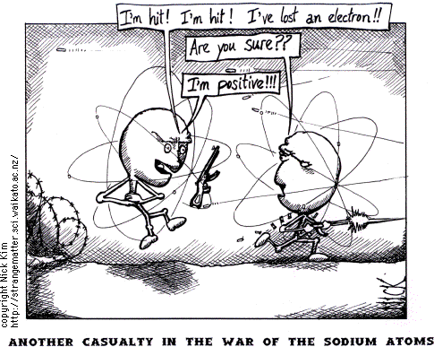

Welcome To Marine Chemistry:

Science is an exciting study because it enables you to better understand, and develop a belonging to, the world in which you live.

The following guidelines will help you succeed in the course:

1. SAFETY is always first! Please ask before using any instrument or mixing any chemicals; thereby avoiding any accidents. We will talk more in depth about lab safety.

2. Materials: You will need a binder (with paper) for this course. Everything will be kept in the binder in order BY DATE except your lab work. Please keep all papers labeled with the date. You will also need a lab notebook. An ideal lab notebook is a one subject hybrid notebinder (Five Star brand) because it allows you to keep lab handouts with your lab observations.

3. Review Sheets: At the beginning of each chapter or unit, I will give you the review sheet that includes the information that will be on the tests and quizzes for that chapter. It is your responsibility to make sure you learn that material during the unit. Some information will be given in the form of daily notes, other information will need to be gathered from activities, labs, homeworks etc. These will be collected at the end of each unit and kept for midterm and final exam review.

4. Homework: Homework is an important part of this class. Each night, you should review the notes you took in class that day. Then you should complete any additional assignments I have given. Homework is your chance to practice skills and concepts we have learned in class or to prepare for new material that will be presented. If you complete all the assignments, you will get 100 points for your marking period homework grade. If you do not have a homework assignment, your marking period homework grade will be lowered by four points.

5. Participation: Participation and class/lab work give me an idea of what you have learned and where you need additional help. The class will also be more fun if everyone participates actively. THERE ARE NO STUPID QUESTION OR COMMENTS. Please show each other respect so that everyone feels comfortable participating. DISRESPECT WILL NOT BE TOLERATED.

6. Extra Help: I am available most days during lunch B for anything you might need to see me about. I will try to identify students who need extra help from in-class participation and assessments but you are the BEST judge of if you need extra help. My extra help schedule will be posted outside the classroom and on the class website.

6. Email: Occasionally I will use email to contact the class with important information. You must check your school email on a regular basis. If you need to contact me, my email address is jvaughan@ctemc.org.

7. Absences: It is likely that you will be absent at some point this year. If it is a planned absence, you must see me (or contact me) in advance. If you do not, you will not receive credit for the work when you are out.
If you are out unexpectedly, you should check the class website (vaughanchemistry.weebly.com) for the homework and make every attempt to do the assignment before class so you do not fall behind. You will also need to get the notes you missed from a classmate AS SOON AS POSSIBLE. In the event of a longer absence, please speak with me so I can help catch up. Email can be a great way to keep you on track when you are absent.

8. Assessments: We will have tests following each major topic and quizzes within each topic. If you score below an 80 on a QUIZ, you may retake the quiz during lunch to improve your grade up to an 80 (no higher). You will also have lab reports and projects.

9. Cell Phones: Cell phones will not be permitted to be with you during class. On your way to your seat each day, please put your cell phone in the designated spot. Make sure it will not ring or buzz during class. Please pick up your phone on the way out of class.

10. Calculators: For many of the topics we study this year, a calculator will be needed. You will be provided a calculator to use in class. You should have access to a calculator at home for homework.

11. Grading System
  - 60% Primary Assessment
  - 30% Secondary Assessment
  - 10% Other/Homework

CONCENTRATE ON LEARNING – THE GRADES WILL FOLLOW!!

